|  |  |
| --- | --- |
| **Nikon AF-S 70-200mm f 2.8E FL ED VR Lens**  Ống kính Nikon AF-S 70-200mm f/2.8E FL ED VR  Nikon AF-S NIKKOR 70-200mm f2.8E FL ED VR 1 Nikon AF-S NIKKOR 70-200mm f2.8E FL ED VR 5 Nikon AF-S NIKKOR 70-200mm f2.8E FL ED VR 6 Nikon AF-S NIKKOR 70-200mm f2.8E FL ED VR 7 | **Featured information:**   * Format: Nikon F-Mount / FX * Aperture: f/2.8 - f/22 * Six extra-low dispersion elements * Fluorite lenses and HRI   Price : 1200$  **Specifications:**   * **Focal distance:** 70 - 200mm * **Largest Aperture:** f/2.8 * **Smallest Aperture:** f/22 * **Lens Mount:** Nikon F * **Lens Format:** Full-Frame * **View:** 34° 20' - 12° 20' * **Minimum Focus Distance:** 1.1m * **Magnification:** 0.21x * **Optical Components:** 22 Elements in 18 Groups * **Number of Mouth Blades:** 9 * **Focus Type:** Auto focus * **Anti-Vibration:** Yes * **Filter Size:** 77 mm (Front) * **Size:** 88.5 x 202.5 mm * **Weight:** 1430 g |

**Description:**

**Focus quickly**

The Silent Wave Motor delivers fast, quiet, and precise autofocus performance along with full-time manual focus control. An internal focusing design is also used, which maintains the overall length of the lens and supports faster focusing speeds. Four focus buttons are equipped on the lens for easy AF Lock activation.

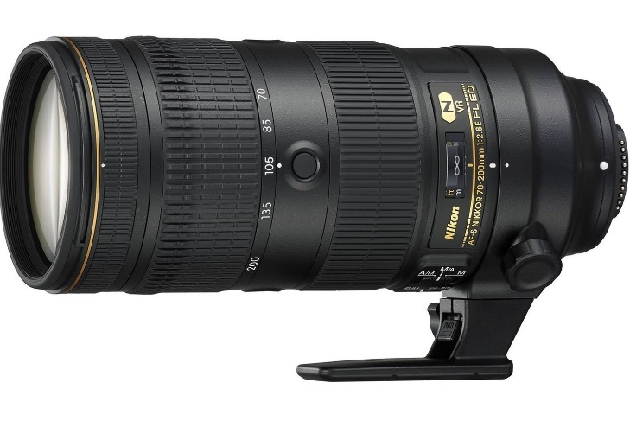

The minimum focusing distance of the lens has been shortened from 1.4 m to 1.1 m. At the same time, the zoom capability increases from 0.11x to 0.21x for improved performance. As a result, you can get closer to subjects to focus, resulting in images similar to close-up shots.

**Design of Nikon AF-S NIKKOR 70-200mm f/2.8E FL ED VR**

The Nikon AF-S NIKKOR 70-200mm f/2.8E FL ED VR lens is a DSLR lens designed for use with Nikon FX sensor cameras. This lens can also be used with DX sensors, providing a 105-300mm equivalent focal length. The sealed design and magnesium alloy construction allow the Nikon AF-S NIKKOR 70-200mm f/2.8E FL ED VR to withstand dust and moisture when working in harsh environments.

